Database Design

Step 1 Build Conceptual Data

Identify entity types

Tangible or Intangible Things
User, Language

Resources
Dictionary, Course, Learner Ranking

Roles Played
Teacher, Learner

Events
Time frame, Time slot, Enroll

Summary
Entity name | Description | Aliases | Occurrence
User | General term describing all person that use MOLA to teach and learn. | MolaUser
Language |  | Language
Teacher | People who use MOLA to teach language and get money. | Teacher
Learner | People who use MOLA to learn language and pay money. | Learner
Course | A series of lectures or lessons in a particular subject. | Course | Each course is created by one Teacher.  A Teacher can create many course. Many Learner can learn a course.
Lesson | An amount of teaching given at one time. | Lesson | Each course has none (free style) or many lessons (structure).
Learner Ranking | A record of a Learner’s work, showing courses taken and grades achieved. | Report, (officially Transcript) | For each Learner, each course has at most one report. A report can record many lesson progress and many slot.
Dictionary | A list of word definition and its pronunciation. | Vocabulary
Time frame | A specified period of time in which teacher is planned to take place. | Frame | A Teacher can register many session. A session can has none or many slot.
Time slot | A meeting of a Teacher and a Learner to conduct a lesson. | Slot | Each slot attended by a single Teacher and a single Learner. Each slot is recorded by one report.

Identify relationship types
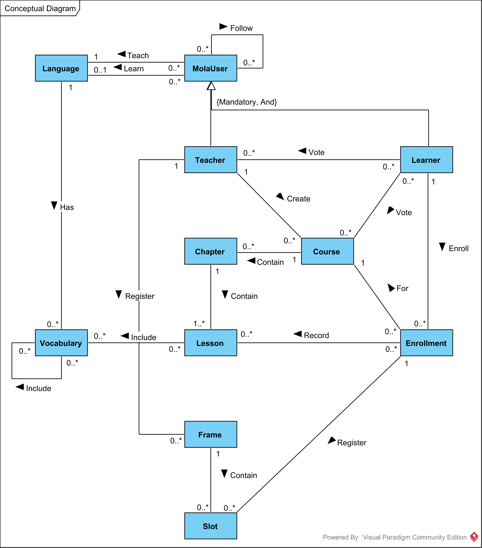

Identify and associate attributes with entity or relationship types
Entity name | Attributes | Nulls | Description
MolaUser | name  firstName  lastName  address  street  district  city  state  country  gender  birthday  email[]  telNo[]  /punctuality | No  No
Teacher | /follower  vote  /count  /average |  | Learner who follow to receive new feed
Learner | /following |  | Following teacher
Course | title  subject  level  description  createDate  publishDate  status  vote  /count  /average | No  No  No  No | E.g. travel, academic, business…  E.g. active, inactive, banned...
Lesson | title  description  duration  createDate | No  No
Enrollment | enrollDate  progress  score | No  No | Percentage of completion, e.g. 80%.
Vocabulary | word  definition[]  pronunciation[] | No  No
Frame | fromTime  toTime | No  No
Slot | fromTime  toTime  teacherLoginTime  learnerLoginTime | No  No
Vote | createDate  comment  score | No  No

Determine attribute domains

Determine candidate, primary, and alternate key attributes
Entity name | Candidate key | Primary key | Alternate key
User | email  telNo | email | telNo
Teacher
Learner
Course | courseNo | courseNo
Lesson
Report
Vocabulary
Session
Slot
Vote | createDate  comment | createDate  comment

Consider use of enhanced modeling concepts (optional step)

Check model for redundancy

Validate conceptual model against user transactions

Transactions

Authenticated User
- List all courses created by a named Teacher.
Teacher → Course
- List all lessons included in a particular course.
Course → Lesson
- List all Teachers by a language.
Language → Teacher
- List all course by a language.
Language → Teacher → Course
- Identify which lesson has learned in a slot
Impossible

Teacher
- List all registered slots by a named Teacher.
Teacher → Session → Slot
- List all enrolled Learners by a named course.
Course → Enrollment → Learner
- Identify the course is registered in a slot
Slot → Enrollment → Course

Learner
- List all courses enrolled by a named Learner.
Learner → Enrollment → Course
- List all leaned lessons in a course for a Learner.
(Learner, Course) → Enrollment → Lesson
- List all available sessions by a named Teacher.
Teacher → Session
- List all registered slots by a named Learner.
Learner → Enrollment → Slot

Final Conceptual Diagram
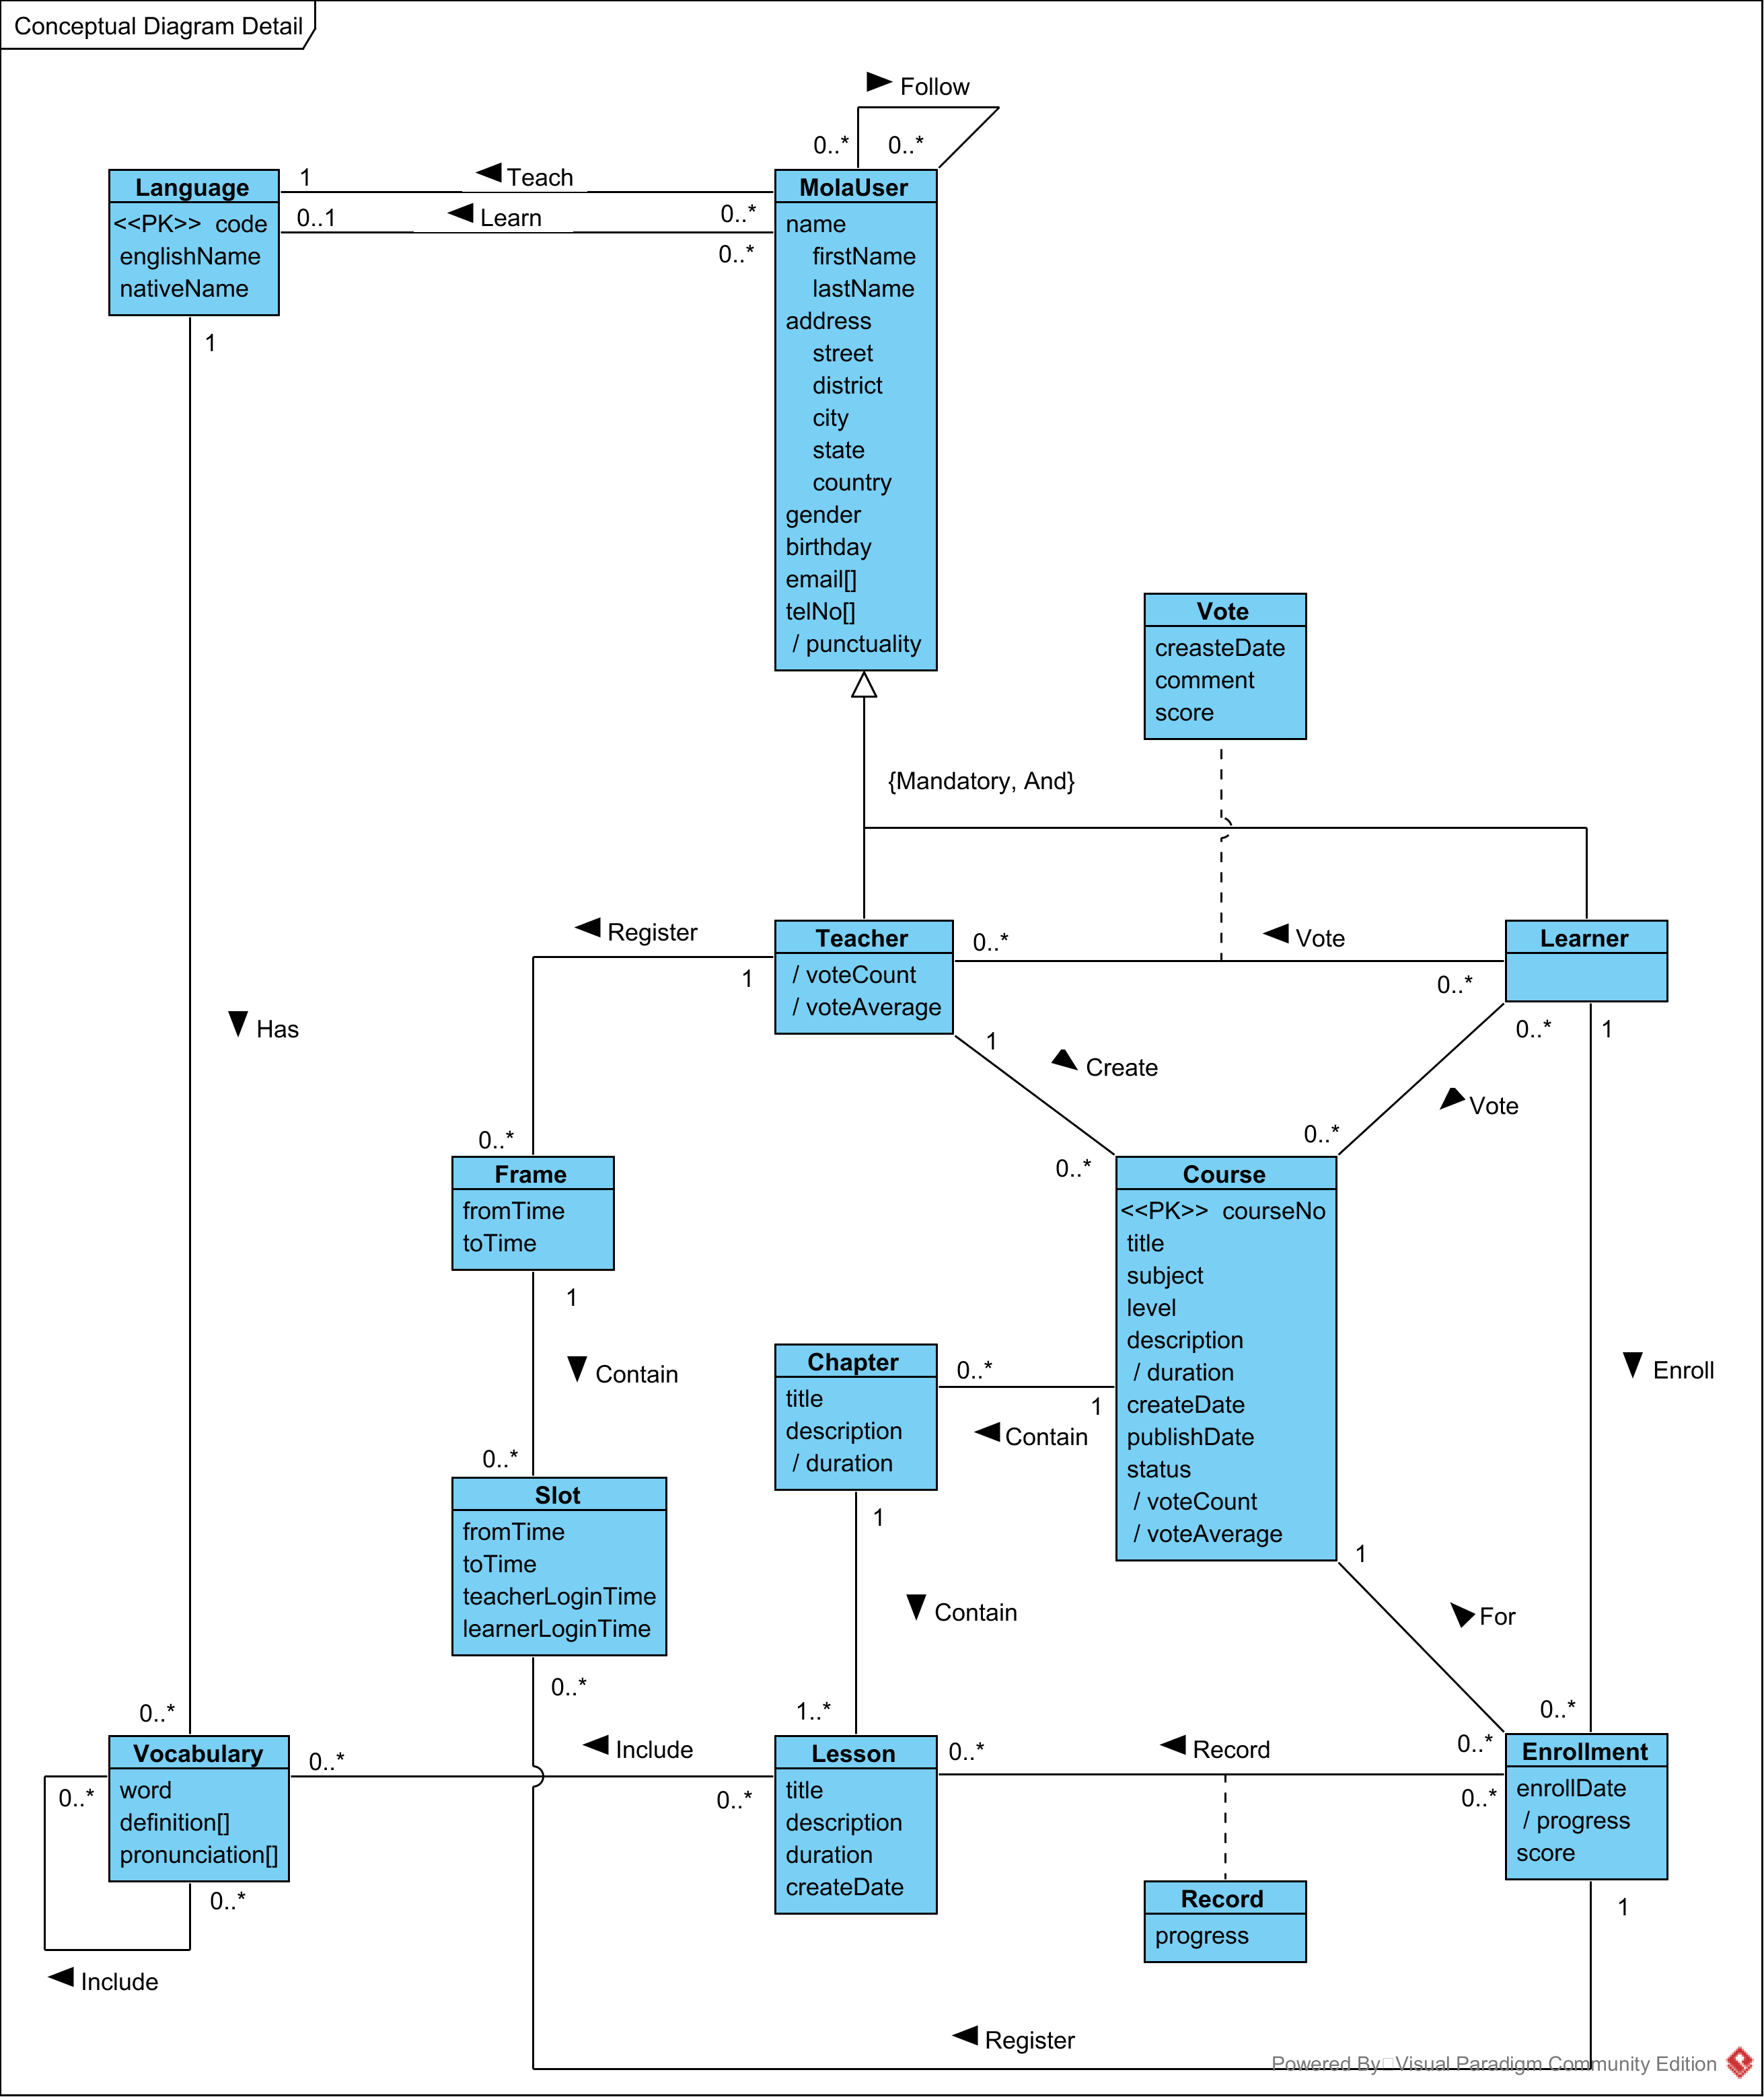

Step 2 Build and Validate Logical Data Model

Derive relations for logical data model

Validate relations using normalization

Validate relations against user transactions

Check integrity constrains

Review logical data model with user

Merge logical data models into global (optional step)

Check for future growth

